<https://youtube.com/live/RQzjnLCSHSM>

<https://www.youtube.com/live/RQzjnLCSHSM?si=TjiUXyEqvA_yVW9T>

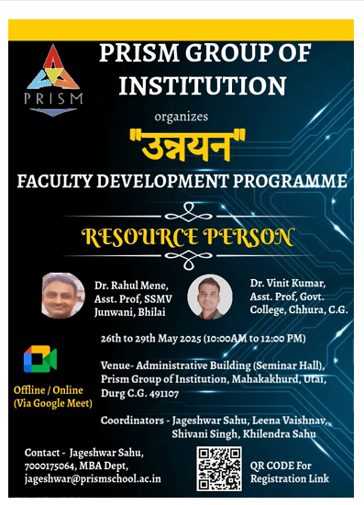

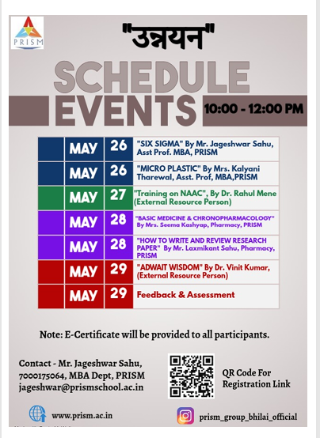

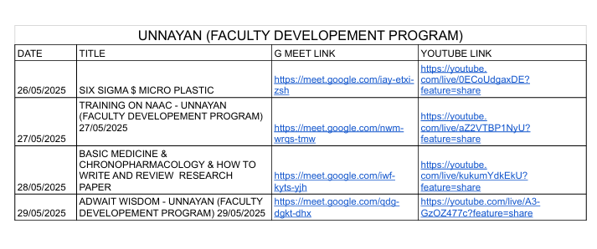

<https://www.youtube.com/live/8GarqAicGPM?si=ZVFikTn44RNzjiu0>



